Volunteer Expenses Form

Name:

Date Submitted:

Signed:

Bank Account Number: Bank Sort Code:

Authorised by:

Please number each journey or item for reimbursement on the table below and attach and number each receipt to match each numbered journey or item. You will be paid by bank transfer.

No. | Journey / Item Description | Date | Cost
01.
02.
03.
04.
05.
06.
07.
08.
 | Total

Travel Expense Form Example

- You must register your oyster or contactless bank card online with Transport for London (TFL) at https://tfl.gov.uk/fares/contactless-and-oyster-account
- Once registered you need to login to get your journey history for the trips you are claiming expenses for.
- Add these trips one line per day to the expense form and number accordingly. See example below:
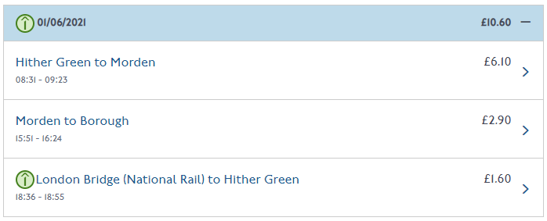

No. | Journey Description | Date | Cost
1 | Return trip to Morden | 01.06.21 | £10.60

- Continue with one line per journey and then total the cost at the bottom.
- Make sure you add in your bank account and sort code details as you will be transferred the money.
- Email the document along with all the corresponding journey history (you can download these from the TFL website) to marta@bost.org.uk
- Please note that there are two payment runs per month made by the BOST finance team in order to process these requests so it may take up to a fortnight for you to be paid these expenses.

For more information about claiming volunteer expenses please ask for a copy of the BOST Volunteer Expenses Policy or contact volunteer@bost.org.uk

